Atlas of Living Australia

# **How to use ALA API credentials to access protected API’s** ([Request API Credentials](https://tokens.ala.org.au/))

**Step 1:** Enter your ALA API credentials into <http://tokens.ala.org.au> or postman tool to generate a JWT token.

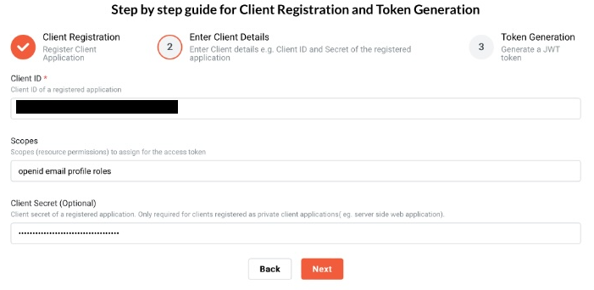

**Step 2:** Initiate a token request to acquire your JWT access_token.

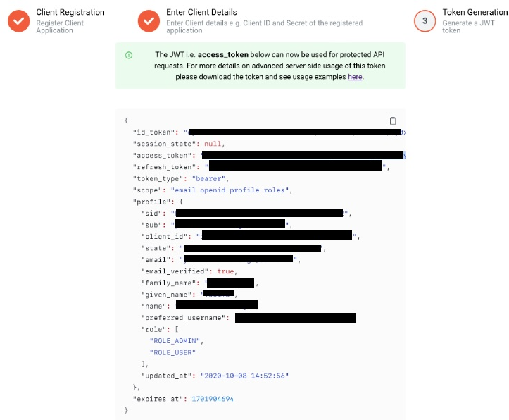

**Step 3:** Gain access to protected APIs by clicking on the padlock icon and entering the JWT Access Token.

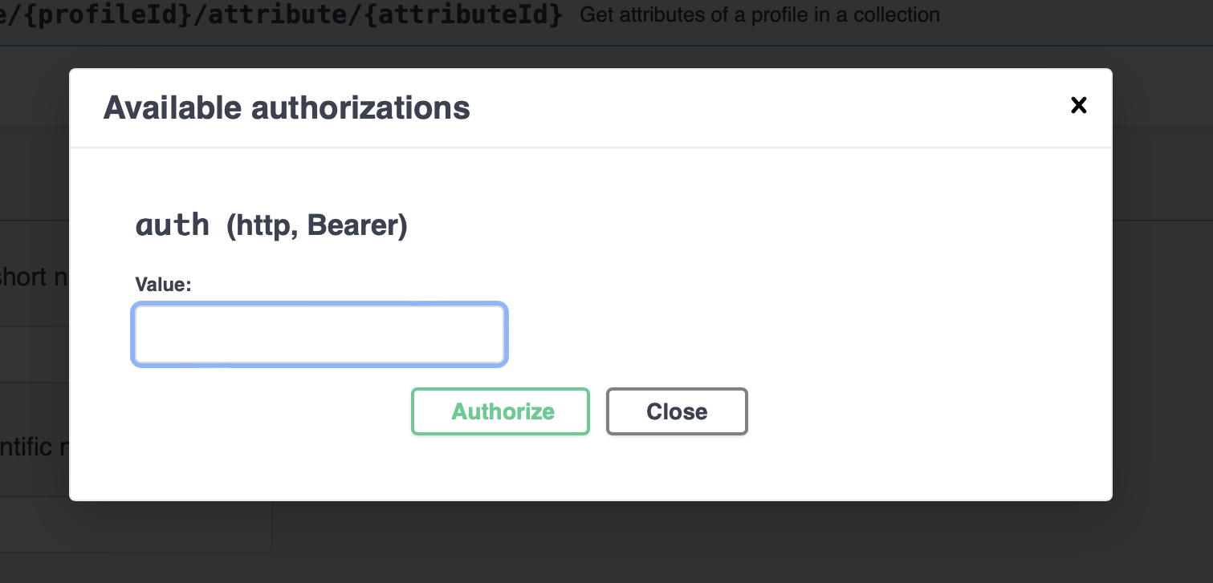

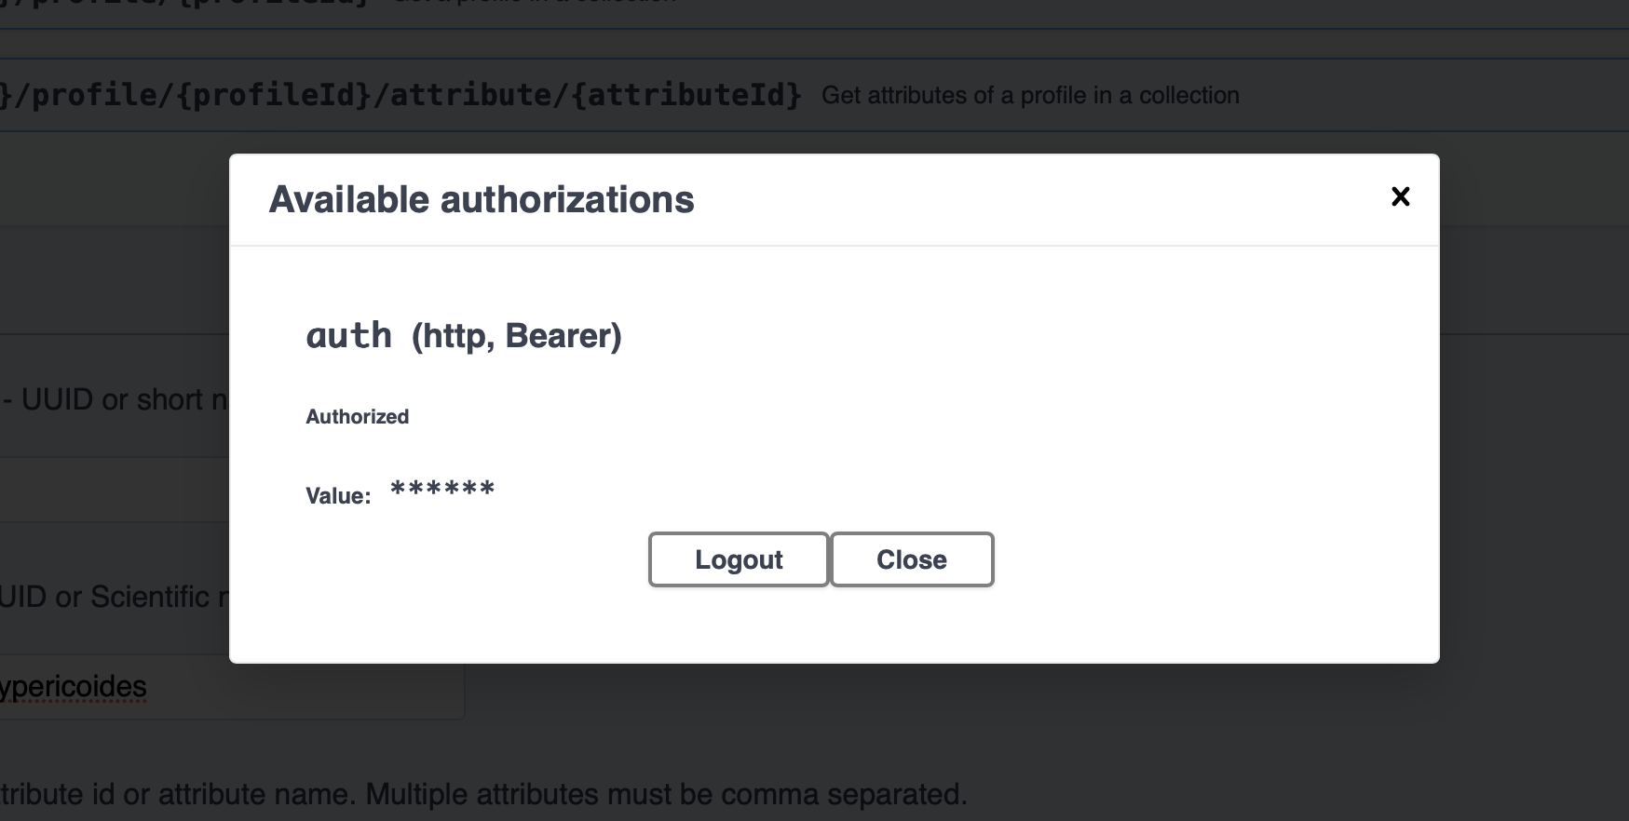

**Step 4:** Try out the protected API.

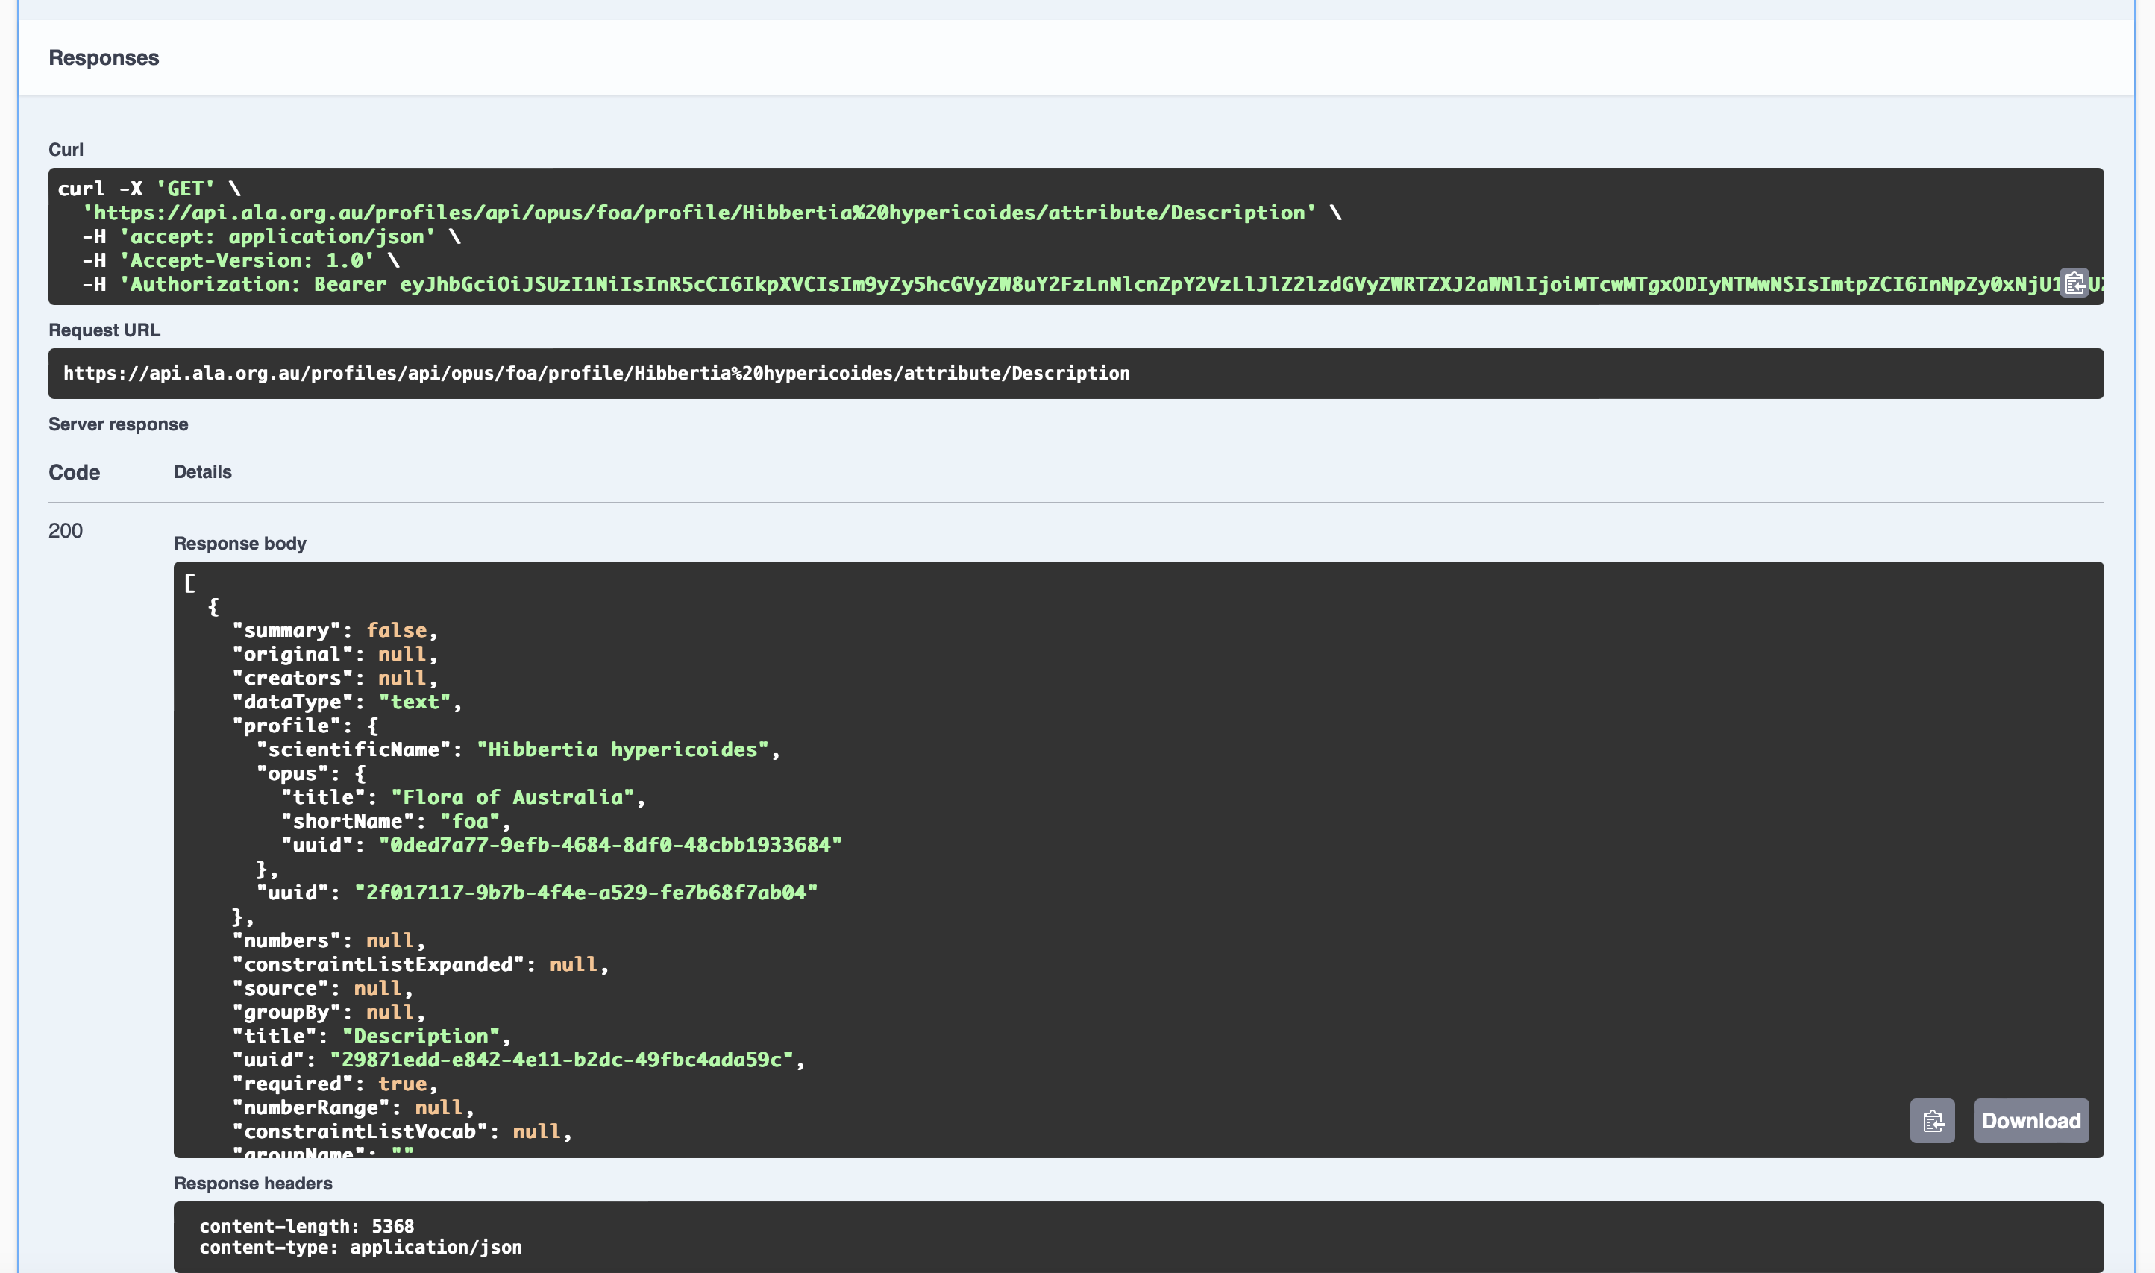

For additional details, visit us at <https://docs.ala.org.au/> or reach out to us at [support@ala.org.au](mailto:support@ala.org.au).